To be placed on inside windscreen / top passenger side

Please ensure that the driver's vision is not impeded

Please ensure that notice is placed away from the dash-cam / camera lens

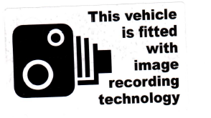

To be placed on the inside rear or side window of the vehicle

Please ensure that the view for the driver is not obscured

